Janis Gonzalez

WEB 335 Introduction to NoSQL

Assignment 3.2 2NF

April 02,2023

Bellevue University

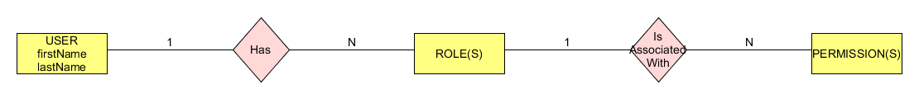

[{

"user": "Eileen",

"roles": [{

"role1": "admin"

},

{

"role2": "owner"

}

]

},

{

"role": "admin",

"permission": [{

"permission1": "system admin"

},

{

"permission2": "owner admin"

}

]

}

]

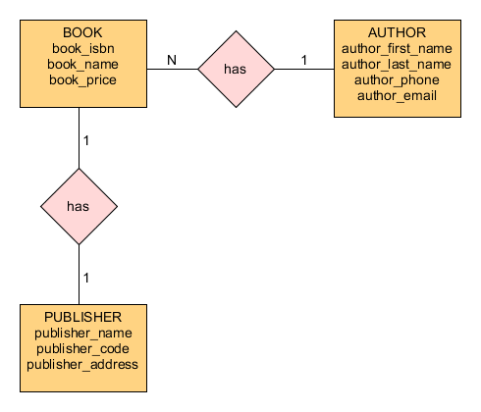  
[{

"publisher_name": "Penguin Random House",

"publisher_code": "32445",

"publisher_address": "2345 Street Avenue, Random City, CA 12345",

"author": [{

"author_last_name": "Goter",

"author_first_name": "Lange",

"author_phone": "123-456-3453",

"author_email": "[glange@yahoo.com](mailto:glange@yahoo.com)"

},

{

"author_last_name": "Gate",

"author_first_name": "Stys",

"author_phone": "123-235-1235",

"author_email": "[gstys@gmail.com](mailto:gstys@gmail.com)"

}

]

},

{

"author_last_name": "Goter",

"author_first_name": "Lange",

"author_phone": "123-456-3453",

"author_email": "[glange@yahoo.com](mailto:glange@yahoo.com)",

"books": [{

"book_isbn": "74537549383405",

"book_name": "Over The River",

"book_price": "43.89"

},

{

"book_isbn": "74537549383403",

"book_name": "Down Under",

"book_price": "55.67"

}

]

},

{

"book_isbn": "74537549383405",

"book_name": "Over The River",

"book_price": "43.89",

"publisher": {

"publisher_name": "Penguin Random House",

"publisher_code": "32445",

"publisher_address": "2345 Street Avenue, Random City, CA 12345"

}

}

]